Really, the AGI Robot

taking Sallie for a ride…

Charles J. Simon
&
André Slabber

Introduction
The Brain Simulator II is a great AGI toolkit, but as mentioned in Charles’ books, true AGI cannot be achieved in a simulated world alone. We simply needed some way of extending Sallie’s adventures into the world of matter beyond the pathways of electrons that make up her ‘physical world’.
Now in order to keep costs to a minimum so this could be an open source project attainable by many, we have not aimed for a fully autonomous robot, but one which has a ‘brain in the basement’ as Charles so aptly put it: the robot itself mainly houses sensors, actuators and control logic, and some form of wireless interface that links it to the Brain Simulator II, so we can experiment with connecting the robot (possibly through some specific module(s)) to the neuron engine which will do the thinking involved in making Really move about and explore his environment.
This document will be a preliminary investigation into what might be required to realize the robot in the first place. Loosely thinking about it, we would probably come to the following short parts list:
- Some platform that is able to move around, preferably on wheels or tracks.
- A battery of some kind, capable of sustaining the system for at least two hours.
- Motor drivers based on the L298 dual H bridge IC to control the four wheel motors.
- A microprocessor board, with sufficient I/O to hook up sensors and actuators.
- A set of sensors, which may grow over time.
- A set of actuators that make the platform do what it is told by the ‘brain in a vat’.
- A connection, either WiFi or 433MHz (BlueTooth range may be too limiting).
- A well-defined interface that sends sensory data and receives action commands.
- The software to translate all serial data to the hardware, and vice versa.
- A ‘sandbox’ for Really to play in, along with some toys…
This, I think, is sufficient to make Sallie in the Brain Simulator II a little brother who will be sent out into a more real world.

the Platform
Various possibilities come to mind when trying to decide what platform to build the robot on. Let’s investigate a few, and explore their pro’s and con’s:

Design a Custom built platform
This may be the best way of achieving exactly what we want, but it will require far more hardware expenses, and far more work hours than any of the other alternatives. As such, my mind discards this as an unlikely path to timely success. On the other hand, plenty of available modules can be combined in meaningful and reasonably simple ways, so maybe this is not all that difficult to use.

Using a recycled robot vacuum or mower
This may be the cheapest option and most ecologically sound, but it will be counterproductive because it is unlikely others will be able to get their hands on the exact same type of ‘wreckage’, and thus following in our design footsteps would be almost impossible.

Start with a readily available platform (kit)
Nowadays, many ready-made or kit robot platforms can be had for prices ranging from $20 for toy-like versions, to almost $400 for professional kits. Since this seems the most sensible way forward, let’s explore this a little further.

Some ready-made options
In the following table we will list a number of the options available on the well-known site banggood.com. Most options will probably also be available on Alibaba, E-bay, Amazon and the like, but this is left as an exercise for those who do not wish to shop at banggood.com for any reason.
Photo | Link | Price | Comments
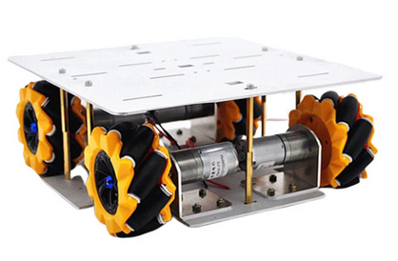 | https://www.banggood.com/D-30-DIY-Smart-4WD-RC-Robot-Car-Chassis-Base-With-Omni-Wheels-DC-12V-1-46-Motor-p-1635787.html | $79.71 | Omnidirectional, Wheels inside platform, double level frame. Just frame and motor/wheel assemblies.
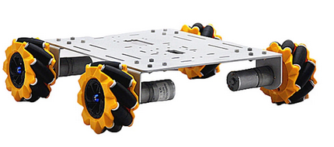 | https://www.banggood.com/D-36-DIY-4WD-Smart-Metal-RC-Robot-Car-Chassis-Base-With-Omni-Wheels-1-46-Motor-p-1631264.html | $76.99 | Omnidirectional, Wheels outside platform, single level frame, less sturdy. Just frame and motor/wheel assemblies.
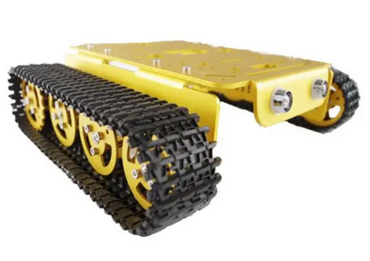 | https://www.banggood.com/T200-Aluminum-Alloy-Metal-Chassis-Tank-Smart-Robot-Car-Kit-for-Arduino-products-that-work-with-official-Arduino-boards-p-1079801.html | $80.20 | Turn-in-place, Wheels outside platform, single level frame, has ultrasonic sensors. Just frame and motor/wheel assemblies.
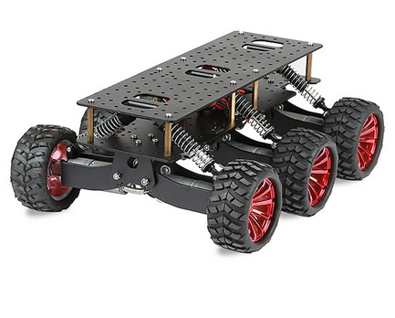 | https://www.banggood.com/Black-or-Blue-6WD-Shock-Absorption-Smart-Car-Wifi-Car-DIY-Kit-Chassis-Off-road-Cimbing-Search-and-Rescue-Platform-Car-p-1400680.html | $144.98 | Turn-in-place, Wheels outside platform, double level frame, suspension for rough terrain. Does have 6 motors, but can be controlled in 2x3 configuration. Just frame and motor/wheel assemblies.
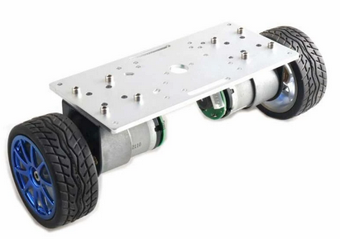 | https://www.banggood.com/2WD-Balance-Car-Chassis-Smart-Robot-Car-Kit-Silver-Panel-or-65mm-Wheel-or-37-520-Motor-with-Code-Wheel--p-1647505.html | $47.99 | Turn-in-place, platform can be any size and shape, just two motors to drive. If we add a platform on top with two trailing wheels front and back, it is a great mobile base.
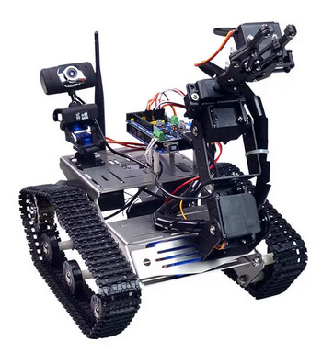 | https://www.banggood.com/Xiao-R-DIY-Smart-Robot-Wifi-Video-Control-Tank-with-Camera-Gimbal-Compatible-with-2560-p-1201938.html | $223.99 | Turn-in-place, may look pricey but actually already has many of the components we would still have to buy and integrate on the other platforms. The processor is an Arduino compatible 2560 board, and battery, charger and camera are included. It also has a robot arm which might be used in later stages.

Even though the last option may be the most ‘bang for our buck’, I will go with option two for now, simply because it appears to give the most directional mobility, being able to go forward, backward, sideways, and turn in place. With more fine-grained control of motor speeds, nice even turns can also be performed. Also, it appears to be the platform with the widest wheel base, making it the most stable option.

the Battery
While the choice of the platform above limits us to a voltage range of 6 to 12 volts because of the motors, this is not really a problem. One might be tempted to go as high as possible in the voltage range, since that would maximize the speed of the motors, but is Really really in a hurry?
A better option would be to select a very standard voltage, because of the easy acquisition of battery and charger. Fortunately the RC model building community has such standards, as the following voltages are readily available in many different capacities:
CODE | VOLTAGE | REMARKS
1S | 3.8 | Too low a voltage for motors of platform
2S | 7.4 | Good enough voltage for motors and Arduino (or any other) board.
3S | 11.1 | Better voltage for motors, use step-down converters for board.
4S | 14.8 | Too high a voltage for the motors

The above table makes it clear that only 2S and 3S are viable candidates, with 3S being preferable because of the higher drive speed (and available capacities). After a brief selection process on banggood.com, the following seems to be a good alternative:


https://www.banggood.com/ZOP-Power-11_1V-8000mAh-35C-3S-Lipo-Battery-T-Deans-XT60-Plug-for-RC-Car-p-1759186.html
At just 46 US dollars, and assuming an average power consumption of 4 Amps, that would still deliver the required 2 hours battery life. Average power consumption will probably be lower, but that is only positive.
The battery charger is a relatively straight-forward choice, that costs another 19 dollars:
https://www.banggood.com/12_6V-3_5A-AC-Lipo-Battery-Charger-XT60-Plug-for-2-3S-Lipo-Battery-p-1343888.html

the Motor Control Boards
We will need hardware to control the four wheel motors from an Arduino. These are based on L298 Dual H Bridge ICs, so both directions can be used. For full mobility using 4 Omniwheels, we will need to be able to control direction and speed of all four wheels independently. The folowing items will provide this:
https://www.banggood.com/2Pcs-Geekcreit-L298N-Dual-H-Bridge-Stepper-Motor-Driver-Board-p-948146.html
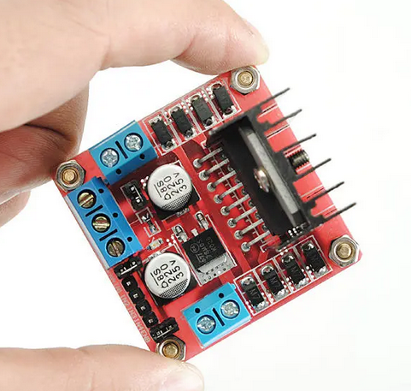
At just $9.44 per two, these boards add another $18.88 to the total bill.

the Processor Board
Because it is most widely used by robot enthusiasts, we will be going with the Arduino 2560 Mega R3, or at least one of its less expensive clones:
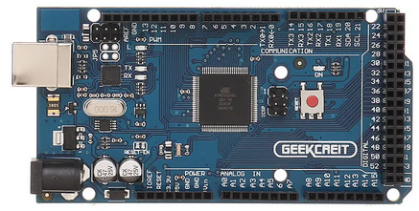

At banggood.com this goes for just under 12 US dollars:
https://www.banggood.com/Geekcreit-MEGA-2560-R3-ATmega2560-MEGA2560-Development-Board-With-USB-Cable-Geekcreit-for-Arduino-products-that-work-with-official-Arduino-boards-p-73020.html
To make patching in the I/O easier, we’ll add the MEGA Sensor Shield, at just 9 US dollars:
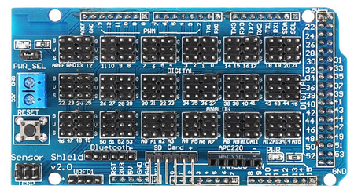

https://www.banggood.com/MEGA-Sensor-Shield-V2_0-Expansion-Board-For-ATMEGA-2560-R3-Geekcreit-for-Arduino-products-that-work-with-official-Arduino-boards-p-78324.html

the Sensors & Actuators
Sensors will be an evolving set, that grows as the robot builds experience, and we make it more challenging. While I am not sure how a new sense channel might be incorporated in the spiking neural net, I do have ideas of which senses we should at least include from the start. The table below will list them in order of necessity as seen for now.
As Charles mentioned in his earlier document, channels should always have feed-backs as well. Just like when we speak, and some echo of our own speech if fed back through the skull to the ears. Or in case of muscle movement, a feedback that tells us how our extremities are positioned. So let’s see what we can come up with:
ACTUATORS | SENSORS | REMARKS
Charging | Battery level | Like we need sleep, Really does have a similar need from time to time.
Driving | Collision | We want to learn not bumping into stuff. At first this will directly be used to cancel moving, but in due time the AGI will learn to avoid these in almost all circumstances.
Commands | GOOD! & NO! | Needed for reinforcement learning of given commands.
Steering | Targeted collision detection | Needed to teach Really to ‘look before he leaps’.
Speaking | Hearing
Display | Vision | The display on the robot may later be used to create expressions like the Terminator trying to laugh, but
Robot Arm | Position and Touch | This would be one of the later additions to the robot, but it would have to have position sensors so the form of the arm is known, and we can detect if the ‘hand’ touches anything.

As mentioned, these sets of actuators and sensors are to be combined into ‘channels’ that get communicated to the AGI and form a sort of duplex channel, that is linked to one or multiple modules in the Brain Simulator II network, so the neurons can learn to interact with them.

the Wireless Connection
Since the 2560 board has three serial connections, it is relatively straightforward to connect any module to it that allows for serial communication. This way we’ll have total control over the interface we design, without having to deal with the added complexity of UDP or TCP communication in the case of WiFi.
Fortunately banggood.com has a nice alternative available:
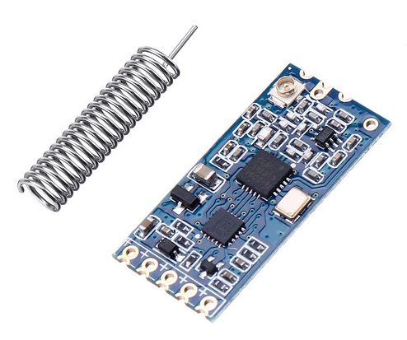
https://www.banggood.com/3Pcs-Geekcreit-HC-12-433MHz-SI4438-Wireless-Serial-Module-Wireless-Transceiver-Transmission-Serial-Communication-Data-Board-Remote-1000M-p-980287.html
This 433Mhz transceiver module is basically used in pairs, and so buying a set of 3 is the economic choice. One can be connected to any of the three serial connections of the 2560 board, and the other can be interfaced to a serial connection of the AGI base station.
Of course this will probably not be sufficient for a video link, but that may be a separate link, possibly through WiFi and totally independent of the 2560 board. Although we may at some point give the AGI a possibility to ‘close its eyes’, the fact that the video goes through a separate route is of little importance.

the Communication Protocol
As discussed above, some high bandwidth signals may go totally outside of the regular protocol, but this is of no consequence since this type of multiple ways of connecting has been done before in for instance high performance RC racing drones. The following things need to be considered when defining the protocol that links up Really to the AGI.
- Since the proposed wireless connection needs to be both ways, we must find out if the 433 MHz modules are truly full duplex, or whether there is a half duplex connection between a pair of transceivers. If only half duplex, then the protocol will have to deal with the “who talks when” aspect of communication.
- Information sent from the sensors of the robot and command signals for the actuators received from the AGI side of the connection will have to be ‘paired’ as mentioned above. This is to make sure their representation on both sides is synchronized as much as possible.
- There will need to be a certain prioritization scheme to make sure the various channels can get their information across in relation to the amount of data they need to communicate, and the urgency of their nature. Urgency might be derived from the spiking rate on the AGI side, or the frequency of updates on the robot’s sensor side.
- Either side should have the possibility for interrupt-type communication if needed. Whether or not we need to actually use this is still a discussion point.

the Software
Not much can be said here yet, except for the fact that the use of the 2560 Mega Arduino makes the Arduino IDE the most useful development environment. Architecture of the software must be based around the communications protocol first of all. If any side of the link is to be the master rather than both being equal peers, the AGI side would have to be the obvious master. After all, it is the interpreting and acting party in this combo, just like our minds are the masters of our bodies.
A basic Arduino program revolves around the setup() and loop() routines, which are the basis for all Arduino programs. If any timed tasks are to be executed without ‘hanging’ the loop() function, this must be incorporated into the program by checking the millis() or micros() relative to some earlier call to the same function. Also, it is possible to connect certain inputs to an interrupt. This may give us the possibility to have priority programming for certain needs.
Come to think of it, it may even be advisable to also use a 2560 Mega Arduino on the side of the Brain Simulator, so we can keep the interface code completely separately of the Brain Simulator II. This would also make it easier to do development on the interface because both ends of the link use the same language and functionality.

the Sandbox
In the Brain Simulator II Sallie lives in a simulated world. Because of that, switching to putting a live robot in a real live world might be too big of a jump. So instead, we will need something of a sandbox or a back yard, where our robot buddy can learn at his own pace.
So imagine a cordoned off area, where the vision of the robot is shielded from any possibly confusing input for the earlier phases of the project. We might paint the various walls in different colors, or add short Q-codes around the world to make for richer interactions.
Also, as Charles did in his simulated world for Sallie, we can add movable panels, mathematical shapes, and other stuff for Really to play with. Of course this is for later phases, when Really has acquired an arm (or maybe two). Movable panels might be used in an earlier phase, when Really does not yet have a movable arm, but perhaps two ‘feelers’ to feel its way around the Sandbox and push movable panels out of the way…

